

#### SRI KRISHNA COLLEGE OF

#### ENGINEERING AND TECHNOLOGY

#### (An Autonomous Institution)

(Affiliated to Anna University, Chennai - 600 025)

Accredited by NAAC With “A” Grade

**JUNE 2024**

# VISIBLE LIGHT COMMUNICATION BETWEEN TWO DEVICES USING LI-FI TECHNOLOGY

## A PROJECT REPORT

***Submitted by***

## ABINAYA M K (727722EUEC004)

## ANANTHAROOPINE K (727722EUEC017)

## DEVAGI S (727722EUEC037)

## BACHELOR OF ENGINEERING

## IN

## ELECTRONICS AND COMMUNICATION ENGINEERING



#### SRI KRISHNA COLLEGE OF

#### ENGINEERING AND TECHNOLOGY

#### (An Autonomous Institution)

(Affiliated to Anna University, Chennai - 600 025)

Accredited by NAAC With “A” Grade

## BONAFIDE CERTIFICATE

## Certified that this project report “VISIBLE LIGHT COMMUNICATION BETWEEN TWO DEVICES USING LI-FI TECHNOLOGY” is the bona-fide work of “ABINAYA M K (727722EUEC004), ANANTHAROOPINE K (727722EUEC017), DEVAGI S (727722EUEC037)” who carried out the project work under my supervision.

**Dr. S. SASIPRIYA Ms. REJINA PARVIN J**

**HEAD OF THE DEPARTMENT SUPERVISOR**

Department of Electronics and Communication Department of Electronics and Communication

Engineering, Sri Krishna College of Engineering Engineering, Sri Krishna College of Engineering

and Communication, Coimbatore – 641008. and Communication, Coimbatore – 641008.

Submitted for the Project viva-voce examination held on___________.

**INTERNAL EXAMINER EXTERNAL EXAMINER**

**ABSTRACT**

In the era of increasing data demands, the exploration of novel communication paradigms becomes imperative. This project delves into the realm of Light Fidelity (Li-Fi) technology, a promising avenue for wireless data transfer. Li-Fi utilizes visible light as the medium for communication, offering unprecedented data transfer rates and enhanced security compared to conventional radio frequency-based methods.

This research aims to design and implement a Li-Fi based data transfer system to facilitate seamless communication between two devices. The project will involve the development of robust Li-Fi transceivers capable of encoding and decoding data through modulating light signals. Through experimentation and optimization, we seek to achieve high-speed data transfer rates while ensuring reliability and stability in varying environmental conditions.

Additionally, considerations will be given to the security aspects of Li-Fi communication, including encryption techniques to safeguard data integrity and privacy.

**BASIC PRINCIPLE**

The Li-Fi communication system represents a cutting-edge approach to data transfer between two PCs, harnessing the power of visible light as a medium. At the transmitting end, a Python script meticulously converts file data into a binary stream, readying it for transmission. This binary stream is then relayed to an Arduino board through a serial connection, where it undergoes transformation into light pulses. Each bit of data is carefully encoded into light signals, modulating an LED in a manner that precisely mirrors the original data sequence. On the receiving side, another Arduino, equipped with a photodiode, intercepts these light pulses and dutifully converts them back into electrical signals. Through this process, the original data is faithfully reconstructed, poised for transmission to the receiving PC. Here, a Python script adeptly captures the incoming data stream via serial communication, meticulously piecing together the original file. Together, these hardware and software components orchestrate a symphony of data transfer, seamlessly bridging the gap between digital information and the tangible world of light. With its fusion of Arduino-based precision and Python-driven flexibility, the Li-Fi communication system stands as a testament to the boundless potential of modern technology in facilitating secure, efficient, and innovative data transmission.

**BLOCK DIAGRAM**

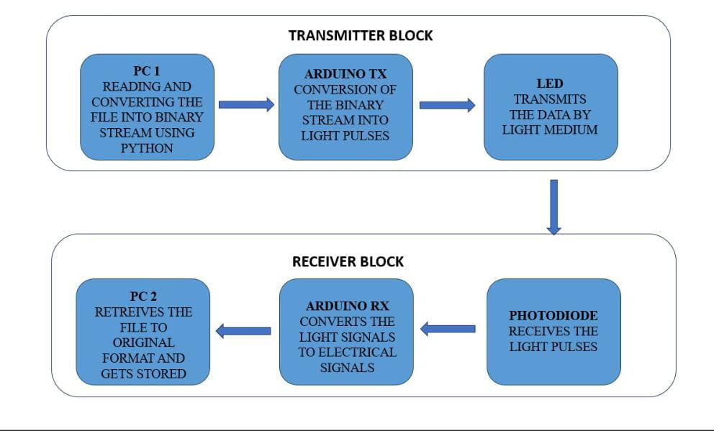

**AREA OF INTEREST**

1. Smart Home Automation:

Li-Fi-Enabled Smart Lighting: Develop an embedded system that uses Li-Fi for both illumination and data communication, enabling smart home devices to communicate through existing lighting infrastructure.

Secure Home Networks: Implement a secure home network where IoT devices such as security cameras, sensors, and appliances communicate via Li-Fi, enhancing security by preventing external hacking attempts.

2. Healthcare Monitoring Systems:

Hospital Communication Networks: Design an embedded Li-Fi communication system for hospitals to reduce RF interference with medical equipment, ensuring reliable data transmission between monitoring devices and central systems.

Patient Monitoring: Use Li-Fi to connect patient monitoring systems, enabling real-time data transmission of vital signs without the risk of interference or data breaches.

3. Underwater IoT Systems:

Underwater Communication: Create an embedded system for underwater IoT devices, using Li-Fi to enable communication between underwater sensors, vehicles, and surface stations.

Environmental Monitoring: Use Li-Fi in underwater sensors for monitoring environmental parameters like water quality, temperature, and pollution levels, transmitting data to above-water stations.

**CHAPTER 2**

**LITERATURE SURVEY**

**EXISTING METHODOLOGIES**

**2.1 Wi-Fi:**

Wi-Fi (Wireless Fidelity) technology allows devices to connect wirelessly to a local area network (LAN) using radio waves, providing high-speed internet access and enabling communication between devices in homes, businesses, and public spaces. Wi-Fi operates primarily in the 2.4 GHz and 5 GHz frequency bands, with the latest Wi-Fi 6E standard also utilizing the 6 GHz band to offer increased channels and reduced congestion. Key features include high data transfer rates, with modern standards like Wi-Fi 6 (802.11ax) achieving speeds up to several gigabits per second, and wide coverage that can be extended using additional access points or mesh networks. Wi-Fi standards, defined by the IEEE 802.11 family, ensure backward compatibility, allowing older and newer devices to coexist on the same network. Security protocols such as WPA3 provide robust encryption to protect against unauthorized access. Wi-Fi technology, encompassing standards from 802.11b with 11 Mbps data rates to 802.11ax with multi-gigabit capabilities, is essential for fast, reliable, and secure wireless communication across various applications and environments.

**2.2 Bluetooth:**

Bluetooth technology is a wireless communication standard designed for short-range data exchange between devices using short-wavelength UHF radio waves in the 2.4 GHz ISM band. Known for its low power consumption, Bluetooth is ideal for connecting peripherals like headphones, keyboards, and mice, as well as for enabling communication between IoT devices and wearable technology. Bluetooth operates over distances typically up to 10 meters (33 feet), although newer versions can achieve ranges up to 100 meters (328 feet) under optimal conditions. The technology supports various data rates, with Bluetooth 5 offering up to 2 Mbps and improved range and broadcast messaging capabilities. Bluetooth also includes features like adaptive frequency hopping to minimize interference, and secure connections with features like pairing and encryption to protect data privacy. Versions of Bluetooth have evolved from the original Bluetooth 1.0 to the latest Bluetooth 5.3, each bringing enhancements in speed, range, and energy efficiency. Bluetooth is widely used in consumer electronics, automotive systems for hands-free calling, and medical devices, making it a versatile and ubiquitous technology for seamless, low-power wireless communication.

**2.3 Zigbee:**

Zigbee technology is a specification for a suite of high-level communication protocols using low-power digital radios to create personal area networks (PANs) designed for small, low-power devices. Operating primarily in the 2.4 GHz frequency band, with options for 868 MHz (Europe) and 915 MHz (USA), Zigbee supports data rates up to 250 kbps, which is sufficient for sensor and control applications. One of its standout features is its low power consumption, enabling devices to have long battery lives, often for several years. Zigbee also supports mesh networking, which allows devices to relay data through intermediate nodes to extend the communication range and enhance network reliability. This capability makes it ideal for complex environments like smart homes, industrial automation, and IoT applications where robust, scalable, and self-healing networks are essential. Security is another key aspect, with built-in encryption and authentication protocols ensuring secure communication. Zigbee's scalability allows for networks with up to 65,000 devices, making it suitable for large-scale applications. It is commonly used in smart lighting, home automation systems, healthcare monitoring, and agricultural management, providing a reliable and efficient solution for low-power, low-data-rate wireless communication needs.

**2.4 Infrared (IR) communication technology:**

Infrared (IR) communication technology utilizes infrared light waves to transmit data wirelessly between devices over short distances. These waves are part of the electromagnetic spectrum with frequencies higher than those of microwaves, yet lower than those of visible light. Infrared communication typically operates within the wavelength range of 700 nanometres to 1 millimetre. This technology is widely used in remote controls, data transfer between devices like smartphones and printers, and proximity sensors. Infrared communication relies on line-of-sight transmission, meaning that there must be a direct, unobstructed path between the transmitting and receiving devices. This limitation ensures that communication is generally secure, as it reduces the risk of interception by unintended recipients. However, it also restricts the range of communication to relatively short distances, typically within the same room or immediate vicinity.

**2.5 5G:**

5G, or Fifth Generation, cellular networks represent the latest evolution in wireless communication technology, promising significant advancements in data speed, capacity, and connectivity. Operating at higher frequencies than previous generations, such as millimeter waves (mm Wave), 5G offers unprecedented data rates, potentially reaching multiple gigabits per second. This enables lightning-fast downloads, seamless streaming of high-definition content, and low-latency applications like real-time gaming and augmented reality. Beyond speed, 5G networks boast enhanced capacity, allowing for more simultaneous connections and supporting the ever-growing number of Internet of Things (IoT) devices. Additionally, 5G promises ultra-reliable and low-latency communication (URLLC), crucial for applications like autonomous vehicles, remote surgery, and industrial automation. With its transformative potential, 5G is poised to revolutionize industries, enable innovative services, and drive the next wave of digital transformation.